Use this same template every day, for every task, throughout all 6 phases. Fill in every field before submitting.
1 | 📋 Intern & Task Details

Intern Name | Mohamed Imthiyas A
Phase / Day | 1
Date | 01/07/2026
Task / Topic Title | Python Foundations — Build Your First Real Script
Time Spent (hrs) | 0.7

2 | 📝 Summary of Work Done
2–4 sentences: what did you build or learn today?
Successfully set up the Python development environment and completed the assigned profile card application. The task emphasized writing clean, well-structured code using appropriate data types, formatted output with f-strings, and basic calculations to generate dynamic information. It served as a practical introduction to the coding standards and workflow that will be followed throughout the program.

3 | 👣 Steps Followed
List the key steps you completed, in order.
1. Set up the Python development environment and activated a virtual environment.
2. Created the required Python files (day1_setup.py and about_me.py).
3. Implemented the developer profile card using appropriate data types and f-strings.
4. Added comments, verified data types using type(), and included the bonus calculation.
5. Executed the program successfully and verified the output in the terminal.

4 | 🧩 Challenges Faced & How You Solved Them

No significant challenges were encountered. The tasks were straightforward, and the development environment and program execution were completed successfully.

5 | 💡 Key Learnings
What’s the one thing you understand better now than this morning?
- Importance of working within a virtual environment for project isolation.
- Writing clean and readable code using meaningful variable names, comments, and f- Strings.
- Structuring a simple Python program with appropriate data types and dynamic output generation.

6 | 🔗 Proof of Work

File(s) / Folder Name | Innolift/Day 1 /about_me.py
GitHub Repo Link
Screenshot Attached? | 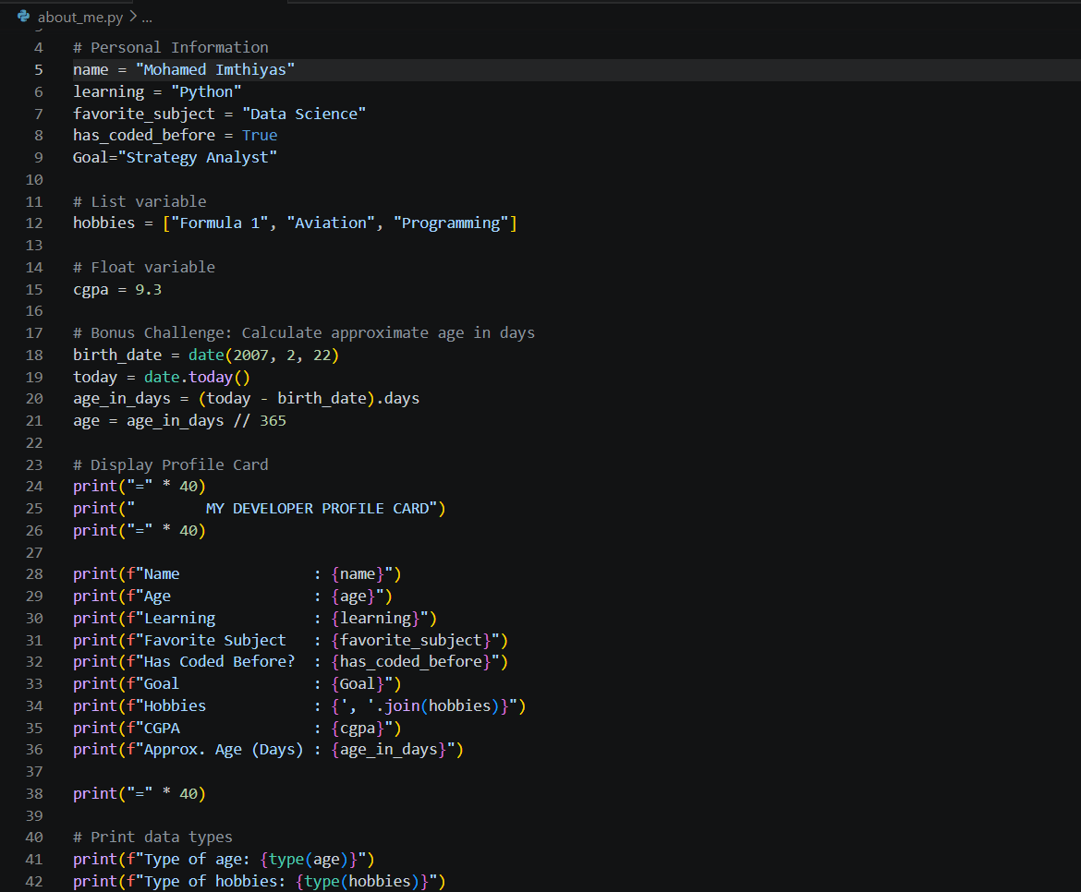  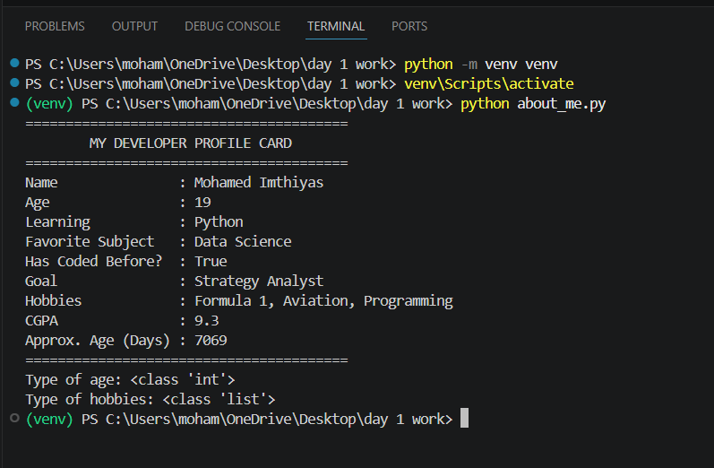
Live/Deployed Link (Later Phase)

7 | ⭐ Self-Assessment

Star Rating | ⭐ ⭐ ⭐ ⭐ ⭐  (circle or fill in stars — 1 = needs help, 5 = fully confident)
Comments | The session was well organized and practical. Looking forward to the upcoming hands-on projects and advanced topics.

8 | 🎯 Mentor Feedback (left blank by intern)

Status
Comments

